YEAR 10 SCIENCE
PHYSICAL SCIENCES
REVISION

1. A person wants to go from Bunnings Belmont to Kmart Belmont. Use the scale on the map to work out:

(a) the distance between the two stores.

(b) the displacement of the person. Remember - this is in a straight line and you need to estimate the bearing (angle).

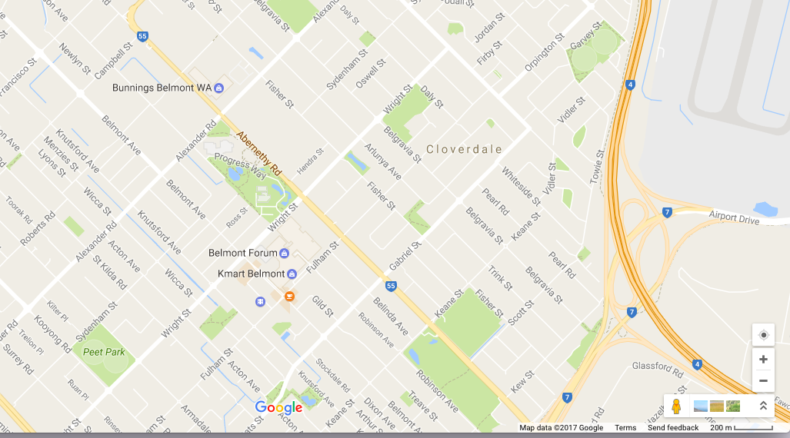

2. Complete the following table. Make sure you include the appropriate units for each quantity.

Distance travelled | Time taken | Average speed
100 m | 20 s
3000 m |  | 15 m/s
 | 15 s | 20 m/s
2000 m |  | 25 m/s

3. What is the speed of a sprinter who runs 100 m in 12.5 seconds?

4. What distance does a plane cover in 3.5 hours if it is flying at 550 kmh?

5. How long will it take a horse moving at 14 m/s to do one lap of an 840 m track?

6. Complete these statements about Newton’s three laws of motion.

(a) An object remains at rest, or will not change its speed or direction, unless ...

(b) When an unbalanced force acts on an object, the mass of an object affects ...

(c) For every action, there is ...

7. Complete the following table.

Force | Mass | Acceleration
100 N |  | 5 m/s²
 | 0.300 kg | 4 m/s²
1.2 N | 2 kg

8. Explain why the following statement is false:
A car travelling along a straight road has no forces acting on it.

9. Explain in terms of Newton’s First Law of Motion why it is dangerous to have loose objects inside a moving car.

10. Use Newton’s Second Law to calculate answers for the following.

(a) A 1400 kg car accelerates at 3.0 m/s². What size force is needed to cause this acceleration?

(b) A force of 160 N causes an object to accelerate at 2.0 m/s². What is the object’s mass?

(c) A force of 210 N acts on a mass of 70 kg. What is the acceleration?

11. A motorcyclist travelling at 32 m/s brakes uniformly for 5.0 seconds to slow for some roadworks, moving through them at 12.0 m/s. What is the deceleration of the motorcyclist?

12. A car is travelling down the highway at 90 km/h when a kangaroo bounces onto the road ahead. The driver takes 1.2 seconds to react and take his foot off the accelerator before braking hard.

(a) How far will the car travel during the time the driver is reacting? (This is called the reaction distance. Remember to convert from km/h.)
(Hint - this is constant speed.)

(b) The car’s brakes can slow the car at a rate of 6.0 m/s². How long will it take for the car to come to a complete stop?
(Hint - the car is slowing down.)

(c) What force must be exerted by the brakes to stop the car if it has a mass of 1100 kg?

(d) The distance over which the car is brought to a stop by the brakes — the braking distance — is found using the equation:
where u is the speed at which the car was travelling when braking commenced and t is the period of time taken for the car to stop. Use the equation to determine the car’s braking distance.

(e) The total stopping distance of the car is equal to the reaction distance added to the braking distance. Calculate the stopping distance of the car.

13. (a)
Explain the difference between mass and weight. Give an example to help your explanation.

(b) The acceleration due to gravity on Jupiter is 22.5 m/s². Calculate the weight of a
450 kg object on Jupiter.

14. Consider the forces acting on a body of mass 40 kg resting on a frictionless surface.

(a) Calculate the net force acting on the body.

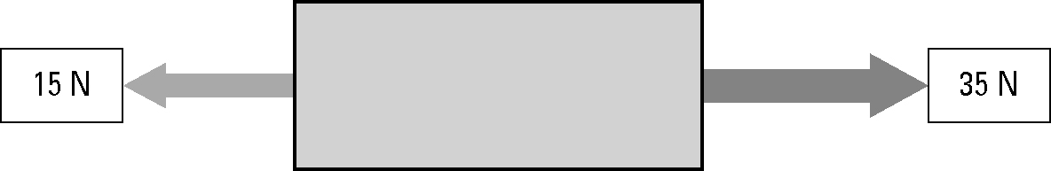

(b) Calculate the acceleration of the body.

15. What is the difference between a primary safety feature and a secondary safety feature?

16. By increasing the time over which a collision occurs, the force of the impact on a car and its passengers can be decreased.

List and describe at least two safety features of a car that decrease the force of impact in this way.

